Simulation of flow Characteristics of

NACA 0015 airfoil using ANSYS-CFD
Suresh Musham, Prasanna S V S N D L, Suresh Kumar .N
Abstract- Airfoil is a streamlined body, when placed in a fluid flow exhibits aerodynamic characteristics. In the present study, aerodynamic characteristics such as lift, drag, velocity magnitude and pressure distribution around the surface of NACA 0015 airfoil are determined by both experimental and simulation analysis. Experimental analysis was conducted at a velocity of 31 m/s for different angle of attack. For numerical simulation analysis CFD- Fluent, k –epsilon turbulence model were used. Further, experimental results were compared with the simulation analysis. Coefficient of lift and pressure distribution from simulation showed good similarities with the experimental results. Parameters viz. Stall angle, Coefficient of Lift, Coefficient of pressure are determined for different angle of attack.

Keywords-Airfoil, fluent, NACA 0015, fluent, k-epsilon
- INTRODUCTION
An airfoil plays a key role in the field of water resources engineering especially in the hydraulic design of reaction turbine guide vanes, aeronautics, mechanics etc. To make use of available resources efficiently airfoil shapes are designed by NACA (National Advisory Committee for Aeronautics) to decrease the drag force on the body. By adopting aifoil shapes the form drag can be reduced drastically. NACA has designed the profile and given a number series which indicates the maximum camber, distance of maximum camber from leading edge and maximum thickness of airfoil as percentage of the chord. Basic nomenclature of an airfoil is shown in Fig.1.Experiments were conducted to improve the efficiency of airfoil in different fields. As experimental work is laborious and time consuming researchers have opted for Computational Fluid Dynamics (CFD). These programs give correct results as experimental methods.
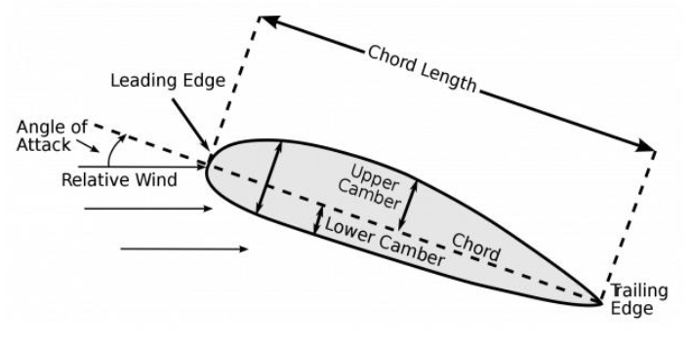
Fig. 1 Basic Nomenclature of an airfoil ^{[8]}

The main scope of the present study was to verify the stall angle and to check the pressure distribution around the airfoil. This was carried out by using experimental and simulation analysis. Further, the experimental results were compared with simulation analysis. Experimental and simulation studies were carried out by many researchers. Vasishtabhargava et al, (2017) evaluated the flow characteristics around the surface of the wings or blades for determining the pressure distribution on airfoil profile. Pressure distribution of NACA airfoil profiles was calculated using the numerical panel method for 2D lift air flow conditions. The analysis of airfoil geometry subjected to various Angle of Attack (AOA) including the stall angles was considered to observe the variation in pressure coefficient along the chord ^{[1]}. V. B. Swami et al, (2017) considered a standard airfoil NACA 0015and was analyzed in ANSYS FLUENT to determine the coefficient of lift and coefficient of drag for 0°, 5°, 10° and 15° at 17 m/s velocity. It is observed that stalling angle attained at 16° AOA and coefficient of lift increased with increasing AOA up to stall angle. Further, increase in angle of attack decrease the coefficient of lift ^{[2]}. Robiul Islam Rubel et al, conducted experiment on NACA 0015 airfoil at 8.5 to 9.65 m/s velocity from 0 to 18° AOA. Simulation was also done in ANSYS 14.0 and results were compared with experimental observations. Their studies reviled that, the lift coefficient increases with increasing Reynolds number to a certain point and decreased thereafter. The velocity is zero at stagnation point and pressure is maximum ^{[3]}. Ankan Dash (2016) conducted experiments on NACA 0012 airfoil for 4°, 6°, 8° and 10° at 51 m/s velocity. Experimental results and simulation analysis were compared and concluded that pressure coefficient on the airfoil upper surface was negative and the lower surface was positive, thus the lift force of the airfoil is in the upward direction. The coefficient of pressure difference is much larger on the leading edge, while on the trailing edge it was much lower ^{[4]}. İzzetŞahin et al, (2015) studied the aerodynamic characteristics of NACA 0015 at a velocity of 10 m/s for different angles of attack. Simulation analysis was carried out in Ansys fluent and a C type mesh was used for this study. The maximum lift and drag coefficient was found to be 0.75 and 0.15 for 16° stall angle ^{[5]}.
- METHODOLOGY
A. Analytical calculations:
The analytical computations were performed based on the following equations.

.
Coefficient of lift is calculated to know the amount of lift force exerted on the airfoil for a given velocity is referred in (1)
$C_{L}=\frac{2F}{ρ_{air}{\left(V\right)}^{2}(A)}$ ………………….. (1)

Pressure distribution on the surface of the airfoil is measured using multi tube manometer.
Coefficient of pressure is calculated as referred in (2).
$C_{p}=\frac{{P-P}_{0}}{0.5ρV^{2}}$ …………………… (2)
where,
${ C}_{l}$ - Coefficient of lift
F- Lift force
Ρ- Density of air
A - Projected area of the airfoil
$C_{p}$ - Coefficient of pressure
p - Pressure at a point on the airfoil
P₀ - Stagnation pressure at undisturbed flow
B. Experimental Analysis:
The experiments were carried out in the Fluid Mechanics Laboratory of Department of Civil Engineering, College of Engineering (A), Osmania University, Hyderabad. The wind tunnel adopted in the present study is a low speed short wind tunnel having an inlet, test section and an outlet. Inlet duct (effuser) is an aerodynamically contoured section with contracting area ratio 9:1. The inlet starts with dimension of 900 mm x 900 mm contoured to 1830 mm x1830 mm. The central portion of the tunnel is the test section sandwiched between the inlet duct and the diffuser using flange. It has a 555 mm x 600 mm cross-section (inside) and 2100 mm length. It is provided with a transparent window. The downstream portion of the tunnel is the diffuser. To the end of this an axial flow fan is attached. The diffuser starts with 600 mm x 600 mm square section at the test section and enlarges to 1370 mm diameter at the fan driven end. The schematic diagram of the experimental setup is shown in Fig. 2.
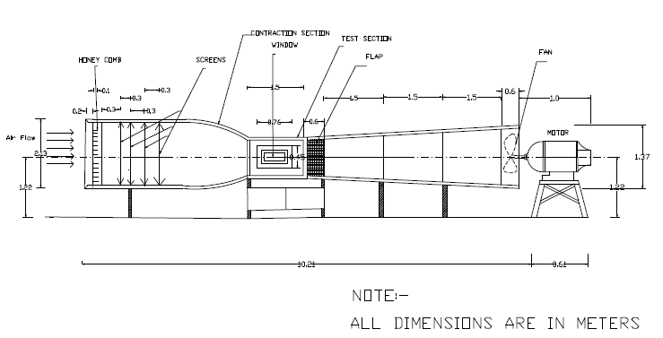
Fig. 2 Experimental Setup
The Experiment is conducted on the airfoil for different angle of attack viz. 0°, 2°, 4°, 6°, 8°, 10°, 12°, 14°, 16° and 18° at 31 m/s velocity. The chord of the airfoil is 20cm. Strain gauge balance is housed beneath the test section portion. Pressure distribution around the surface of NACA 0015 is measure at 0° of AOA. The models are mounted on the vertical mechanical member called string. The lift force was measured using this unit. Multi bank manometer is used for studying the pressure distribution around various models is shown in Fig. 3.
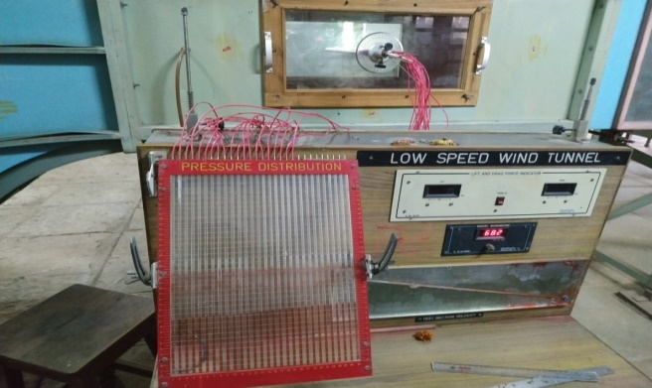
Fig. 3 Two Component Strain gauge balance for low speed short wind tunnel
It is inclined at an angle of 20°. To measure the static pressure inside the wind tunnel manometer is used which is having inclination of 38.6°. A graph is drawn between coefficient of lift and angle of attack is shown in Fig. 4.

Fig 4 Graphical representation of Experimental results

Fig 5 Coefficient of pressure Vs. distance to chord ratio- Experimental result at 0° AOA
C. Simulation process:
In the present study ANSYS – CFD (Fluent) is adopted for simulation analysis. The analysis was carried out using Finite Volume Method (FVM) by k-epsilon turbulence model. A two dimensional NACA 0015 airfoil geometry was generated in ANSYS – Workbench as shown in Fig. 6.
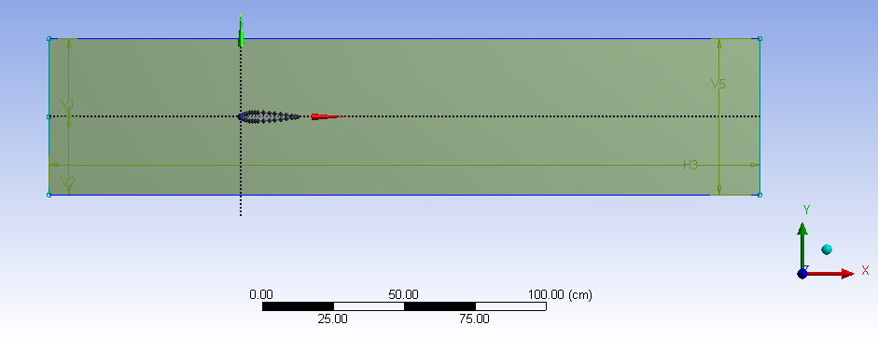
Fig. 6 Geometry of NACA 0015 airfoil
Mesh is generated for airfoil in which edge sizing and refinement methods were adopted. For more accurate simulation refinement was made as shown in Fig. 7. Quality of mesh is tabulated in table 1. Further, mesh was imported imported into the Fluent solver analysis adopted different turbulent models.
Table 1 Details of meshing in Ansys
Parameter | NACA 0015 airfoil
No. of nodes | 4443
No. of elements | 4213
Orthogonal quality | 0.6287

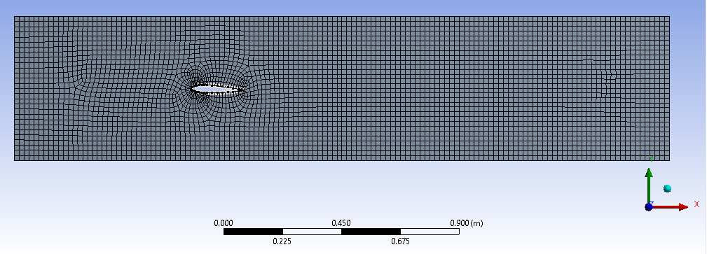
Fig. 7 Meshing of NACA 0015 airfoil
In fluent setup all the boundary conditions were assigned i.e., inlet velocity, outlet pressure, boundaries etc. as shown in Fig. 8. As the experiment is conducted at 30°C, air viscosity inside and outside of the wind tunnel are 1.164 kg/m³ and 1.225 kg/m³ respectively. The simulation is carried out for various velocities using multi-phase analysis. Each flow is analyzed for a time step of 0.01s.
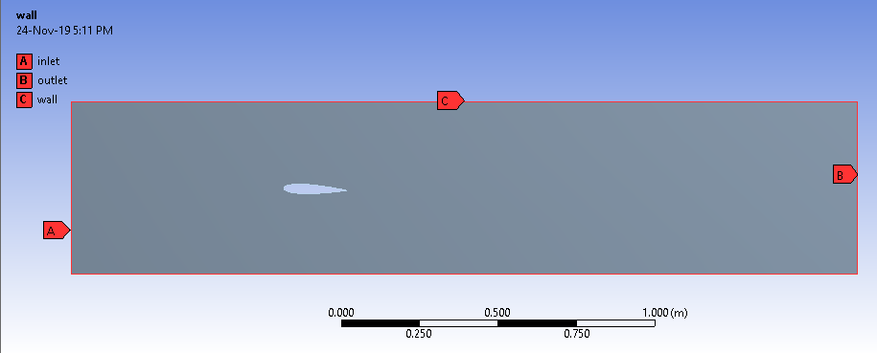
Fig. 8 Boundary Conditions

Table 2 Results of Simulation Analysis- Coefficient of Lift at velocity 31 m/s
AOA(degree) | Coefficient of Lift | Stall angle (degree)
0 | 0.1801 | 14°
2 | 0.1971 | 14°
4 | 0.2184 | 14°
6 | 0.2595 | 14°
8 | 0.4107 | 14°
10 | 0.4421 | 14°
12 | 0.6746 | 14°
14 | 0.6766 | 14°
16 | 0.6601 | 14°
18 | 0.5936 | 14°
Equation (1) is used to calculate coefficient of lift was tabulated in table 2.
Contours are obtained from simulation viz. Contours of static pressure, contours of dynamic pressure and contours of total pressure as shown below.
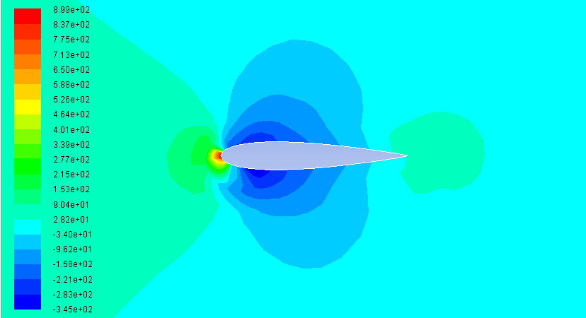
Fig. 9 Contours of static pressure at 0° AOA

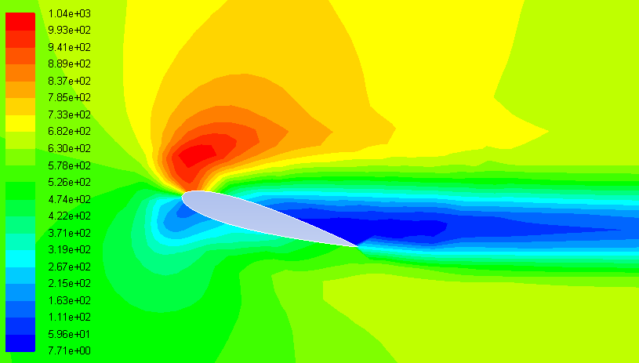
Fig. 10 Contours of dynamic pressure at 16° AOA
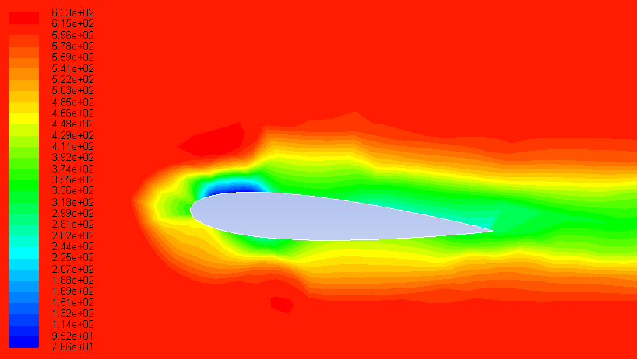.
(a) 4° angle of attack
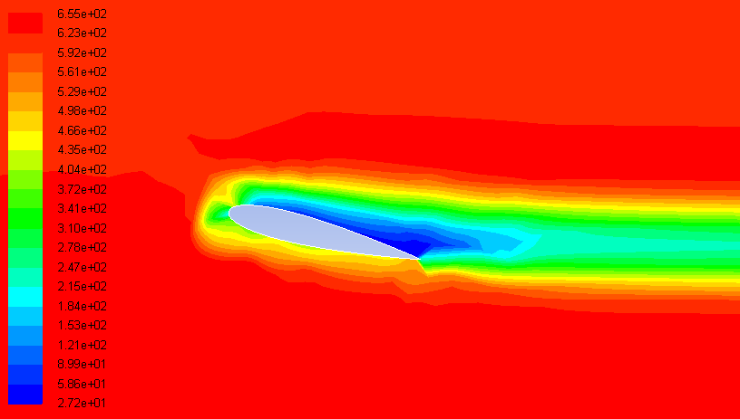
(b) 14° angle of attack
Fig. 11 Contours of total pressure
- RESULTS
Experiment and simulation analysis was conducted and the following results were deduced.
- Experiments were conducted on NACA 0015 airfoil at a velocity of 31 m/s. Stall angle was observed to be at 14° AOA and the pressure distribution on the surface of the airfoil is calculated as referred in (3).
- Stall angle is observed to be at 14° AOA for both experiment and simulation analysis curves coincide at 14° AOA with deviation of -1.77% as detailed in Fig. 12.
- The results obtained from the Fluent solver simulation with multi-phase model for k-epsilon and experimental results show good agreement with each other.

Fig. 12 Variation of Coefficient of lift w.r.to angle of attack

- From simulation results it is evident that, on the top of the airfoil, the flow and the circulation are in the same direction because of which the flow velocity is more and pressure is less.
- The coefficient of pressure on upper surface of the airfoil is negative, while on the lower surface it is positive, from the classic literature.
- The simulations were further carried out for different flow velocities viz. 20 m/s, 25 m/s, 35 m/s to evaluate the stall angle. The results of which are shown in Fig. 13.

Fig. 13 Coefficient of lift Vs AOA
- CONCLUSIONS
Based on the experimental and simulation results the following conclusions are drawn.
- For 0° AOA it is observed that the contours of static pressure over an airfoil are symmetrical and the stagnation point is exactly at the nose of an airfoil. Contours of static pressure for typical cases (0° and 14°) were shown in Fig. 9.
- The dynamic pressure observed to be less on the upper surface of the airfoil towards the trailing edge, which is approximately more than half of the wing surface area as shown in the Fig. 10. This has resulted in reduction the lift force making it maximum at 14° AOA.
- Further, on the lower surface the flow velocity and circulation are in the opposite direction, resulting in low velocity and high pressure. As a consequence of this, the flow lines on the top surface will have less spacing and lines will be wider on the lower surface as shown in Fig. 11
- From the present analysis it is proved that the Stall angle remains constant for a particular type of airfoil at various velocities viz. 20 m/s, 25 m/s and 35 m/s.
- It is concluded from experiment and simulation analysis that pressure distribution on both upper and lower surface of airfoil is symmetrical at 0° AOA.
- Deviation observed for the coefficient of lift is small and could be because of experimental errors or difficulties encountered in extracting simulation results.
REFERENCES
- Vasista Bhargava , Ch Koteshwara Rao, Y.D.Dwivedi, “Pressure distribution & Aerodynamic characteristics of NACA Aerofoils using Computational Panel Method for 2D Lifting flow”, International Journal of Engineering Research, Volume No.6(2017).
- Prof.V.B.Swami, “Computational fluid dynamic analysis of NACA 0015”, international journal of mechanical engineering and technology, volume No.8 issue: 2 Feb 2017.
- Robiul Islam Rubel, Md. Kamal Uddin, Md. Zahidul Islam, Md. Rokunuzzaman, “Numerical and Experimental Investigation of Aerodynamics Characteristics of NACA 0015 Aerofoil”. International journal of engineering technologies Robiul Islam Rubel et al., Vol.2, No.4, 2016

- Ankan Dash, “CFD Analysis of Wind Turbine Aerofoil at various Angle Of Attack”, IOSR Journal of Mechanical and Civil Engineering, Volume 13, Issue Jul-Aug 2016.
- İzzet Şahin and Adem Acir, “Numerical and Experimental Investigations of Lift and Drag Performances of NACA 0015 Wind Turbine aerofoil”. International Journal of Materials, Mechanics and Manufacturing, Vol. 3, No. 1, February 2015.
- Bhushan S. Patil, Hitesh R. Thakare, “Computational Fluid Dynamics Analysis of Wind Turbine Blade at Various Angles Of Attack and Different Reynolds Number”, International Conference on Computational Heat and Mass Transfer-2015
- M. Nazmul Haquea, Mohammad Ali , Ismat Ara, “Experimental investigation on the performance of NACA 4412 aerofoil with curved leading edge planform”.6th BSME International Conference on Thermal Engineering (ICTE 2014).
- Karna S. Patel, Saumil B. Patel, Utsav B. Patel, Prof. Ankit P. Ahuja, “CFD Analysis of an Aerofoil”, International Journal of Engineering Research, Volume No.3, Issue: March2014.
- Mayurkumar kevadiya, Hemish A. Vaidya, “2D ANALYSIS OF NACA 4412 AEROFOIL”, International Journal of Innovative Research in Science, Engineering and Technology, Vol. 2, Issue 5, May 2013.
- M.Kevadiya, “CFD Analysis of Pressure Coefficient for NACA 4412”, International Journal of Engineering Trends and Technology ISSN/EISSN: 22315381 Volume: 4 Issue: 5, 2013.
- M.Arvind, “CFD analysis of static pressure and dynamic pressure for NACA4412” International Journal of Engineering Trends and Technology ISSN/EISSN: 22315381Volume: 4, (2010).
- Prasanna S V S N D L, Suresh kumar N, "Simulation of Flow Behaviour around Bridge Piers Using ANSYS – CFD", International Journal of Engineering Trends and Technology ISSN(online), Volume No.7 issue: sep 2018

AUTHORS PROFILE

Suresh Musham is pursuing his Master of Engineering in Water Resources Engineering at Osmania University, Hyderabad. He graduated from Vasavi college of Engineering in the year 2016.


DR. (Ms.) SVSNDL PRASANNA has obtained her Ph.D. degree from Osmania University, Hyderabad. She received her degree in the year 2019 for her work entitled ‘Turbulence Modeling for Selective Hydraulic Engineering Applications’. She has 12 years of teaching and research experience. She has published about 8 National / International Journals and more than 5 in International and National Conferences. She has delivered 6 guest lectures in reputed Government and Private Institutions.


Prof. N. Suresh Kumar has obtained his Ph.D. degree from IIT., BOMBAY. He received his degree in the year 1998 for his work entitled ‘Jet Mixing in Flocculators’ under the guidance of Prof. B. S. Pani and Prof. S. G. Joshi. He has more than 30 years of teaching and research experience. He transferred the technology developed as a part of his Ph.D. program from lab to land. Provided the process design and drawing for a Jet Flocculator - a component in primary treatment unit of Kitchen effluent treatment plant for ANNAMRITA- ISKCON FOOD RELIEF FOUNDATION, Mumbai. The project site is located at Kanchad village near Wada, Maharashtra. (Completed). He has published 10 National / International Journals and more than 20 in International and National Conferences. He has delivered more than 30 guest lectures in reputed Government and Private Institutions

Revised Manuscript Received on December 22, 2018. Suresh Musham, ME (Civil Engg. dept.), Osmania University, Hyderabad, India Dr. (Ms). S V S N D L Prasanna, Assistant Professor (Civil Engg. dept.), Osmania University, Hyderabad, India Prof. N. Suresh Kumar, Professor (Civil Engg. dept.), Osmania University, Hyderabad, India

